**EXPERIMENT-4**

**TITLE 4. Use of Inbuilt functions and relational algebra operation**

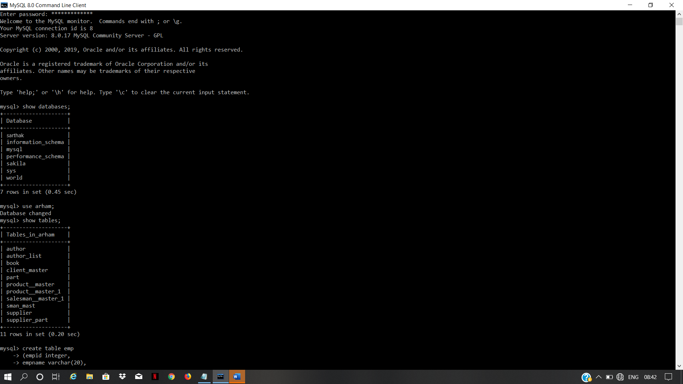



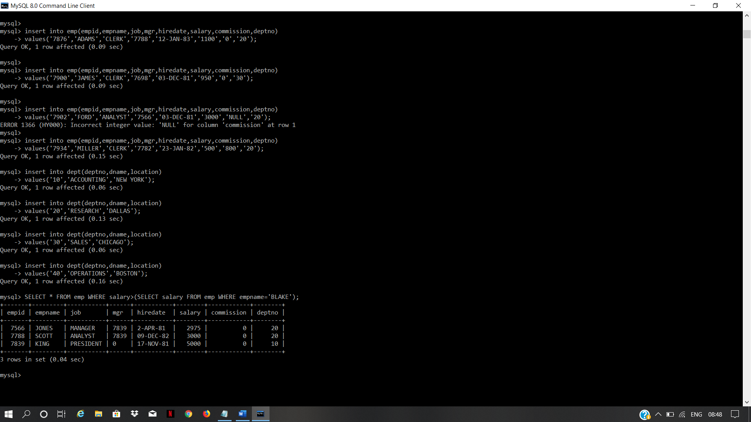

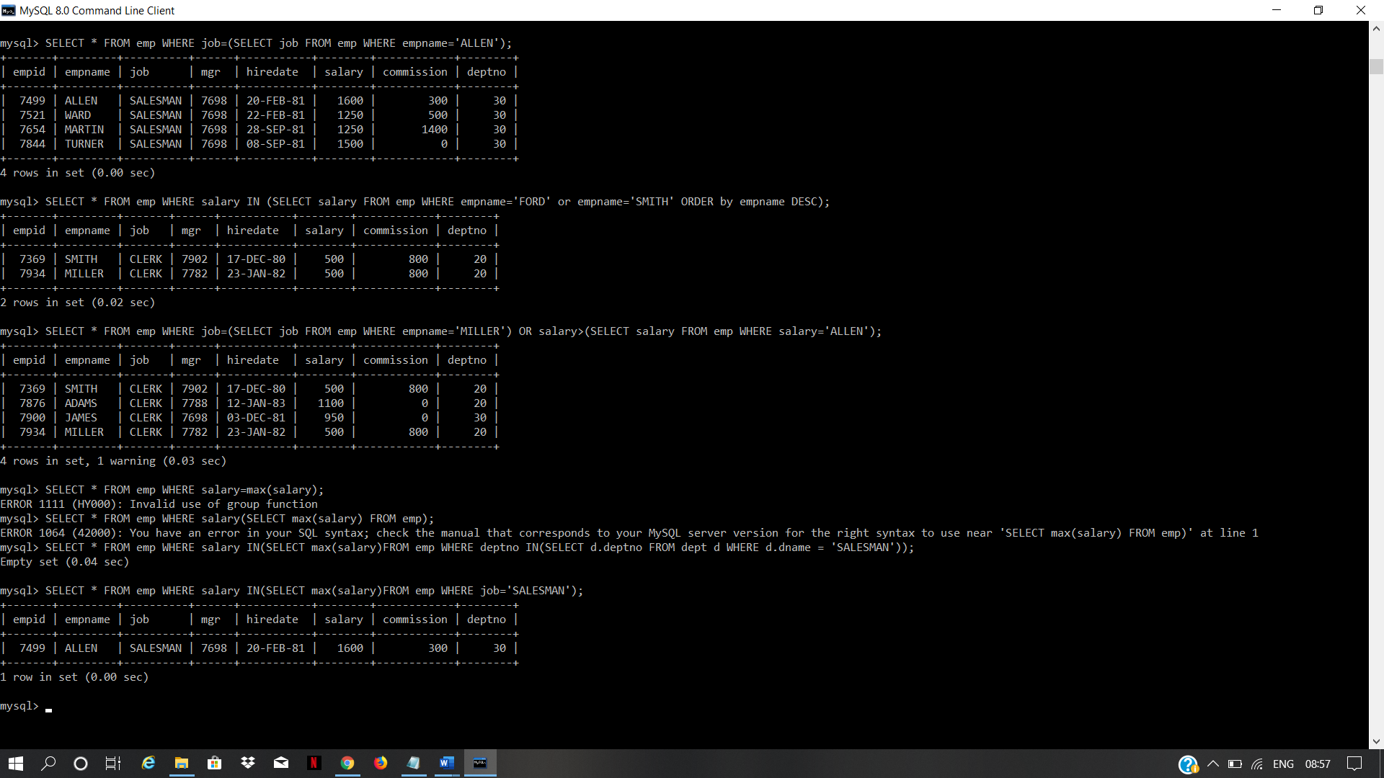

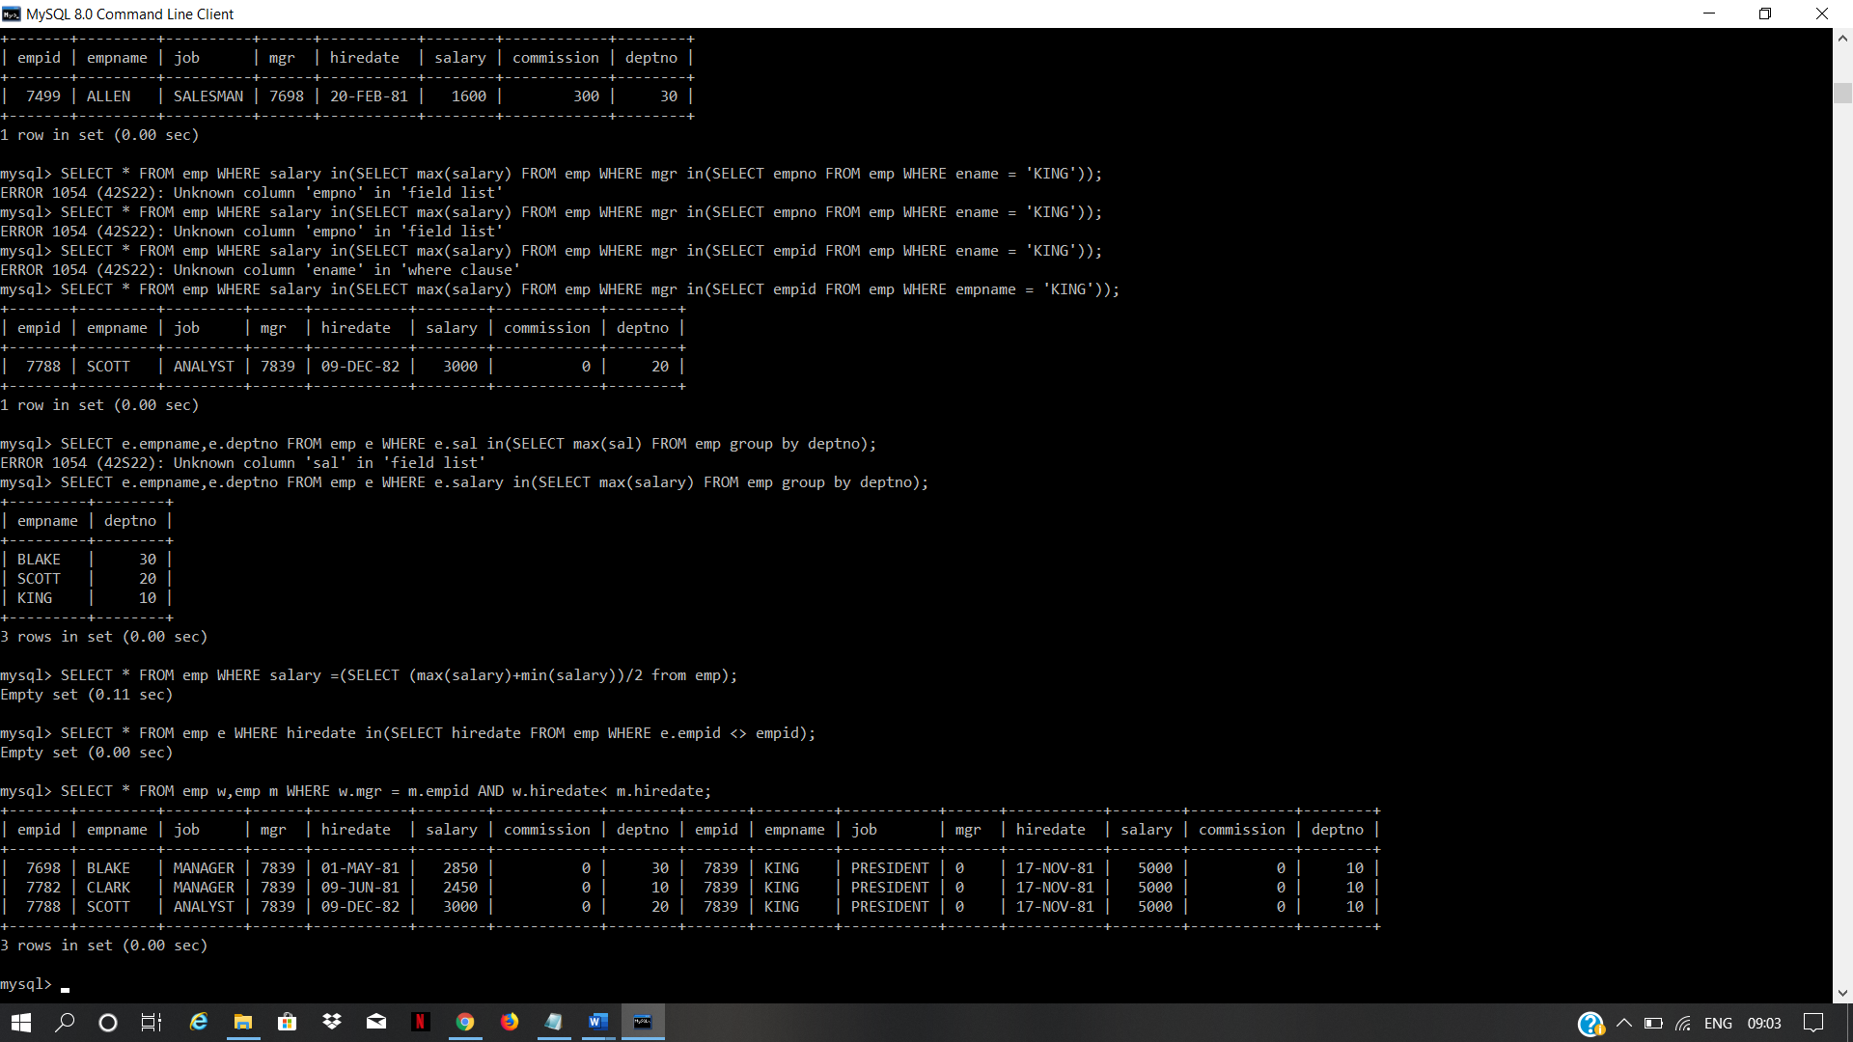

**EXPERIMENT-4**

**TITLE 4. Use of Inbuilt functions and relational algebra operation**

**Write the Nested Queries for the following queries.**

**1. List the details of the emps whose Salaries more than the employee BLAKE.**

**2. List the emps whose Jobs are same as ALLEN.**

**3. List the Emps whose Sal is same as FORD or SMITH in desc order of Names.**

**4. List the emps Whose Jobs are same as MILLER or Sal is more than ALLEN.**

**5. Find the highest paid employee of sales department.**

**6. List the employees who are senior to most recently hired employee working under king.**

**7. List the names of the emps who are getting the highest sal dept wise.**

**8. List the emps whose sal is equal to the average of max and minimum**

**9. List the emps who joined in the company on the same date.**

**10. Find out the emps who joined in the company before their Managers.**